**2: Introduction to Docker, Why Docker, What Problems Docker Solve.**

**What problems we have with Traditional Infra?**

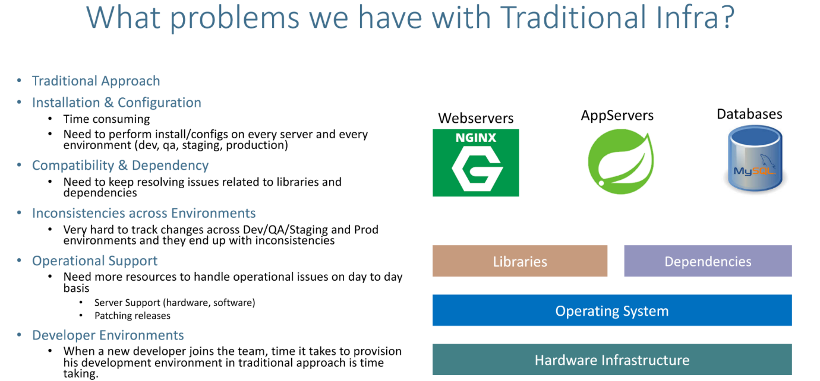

--- **what are the problems with traditional infrastructure…?**

--- **note** - in the traditional infra, we have the hardware infrastructure on top of that. Usually, we installed our respective operating system like ubuntu or centos or RedHat and then when we are planning to deploy our applications, it's equal ant level libraries and Dependencies we install them and handle them.

**What is difference between physical machines and virtual machines**

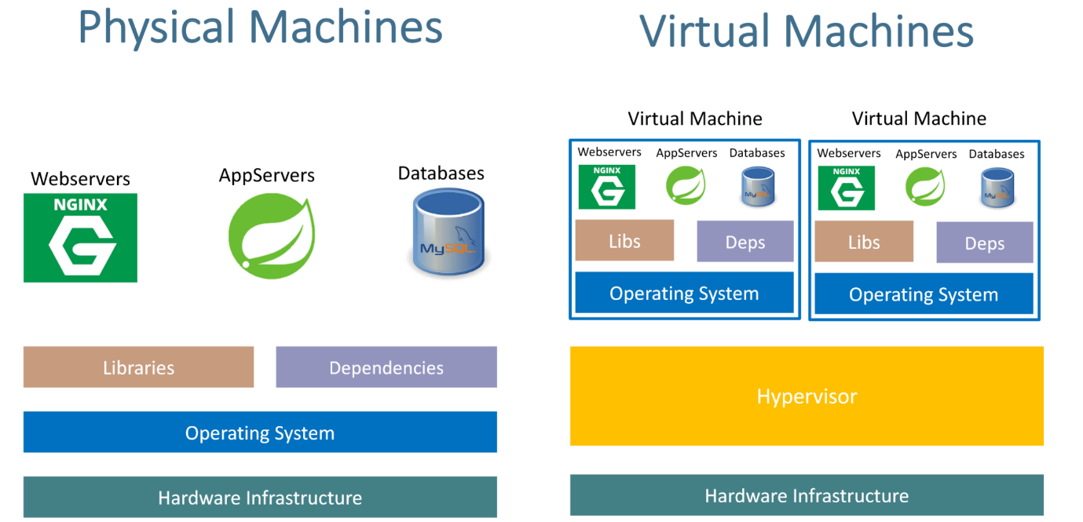

--- **physical machines** – we have the hardware infrastructure, on top of that we have operating system, on top of that we have libraires and dependencies. On top of that we have installed webservers, app servers, Data bases.

--- **virtual machines** - we have the hardware infrastructure, in virtual machines we have the hypervisor, on hypervisor we create the hypervisor. We have the operating system for each virtual machine and then we will install the libs and dependencies on the virtual machines. After that we will install app servers, webservers, databases.

**Physical machine with docker**

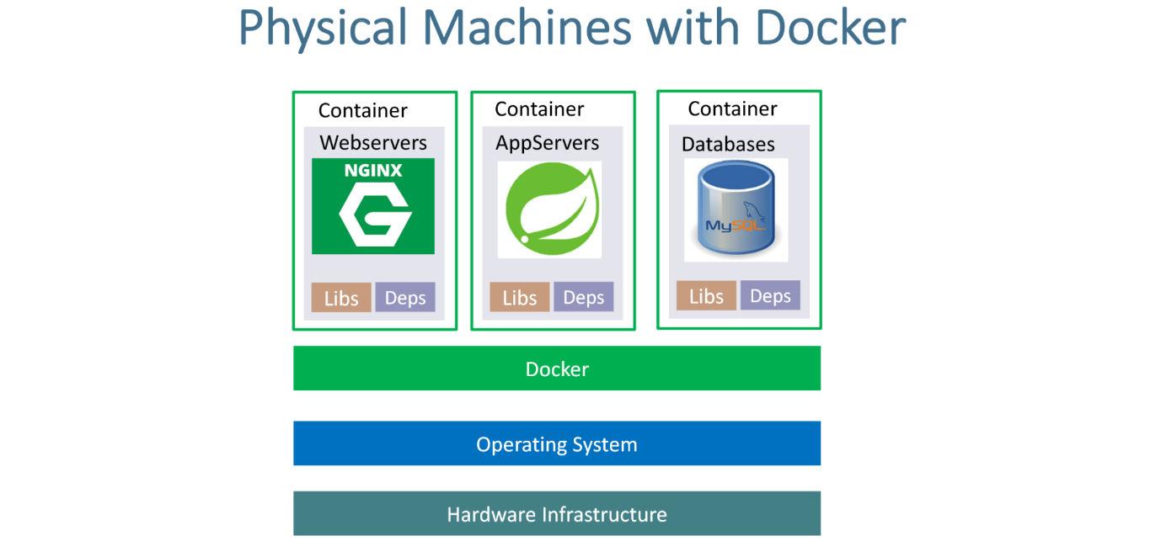

--- on the operating system we will install docker.

**Virtual machines with docker**

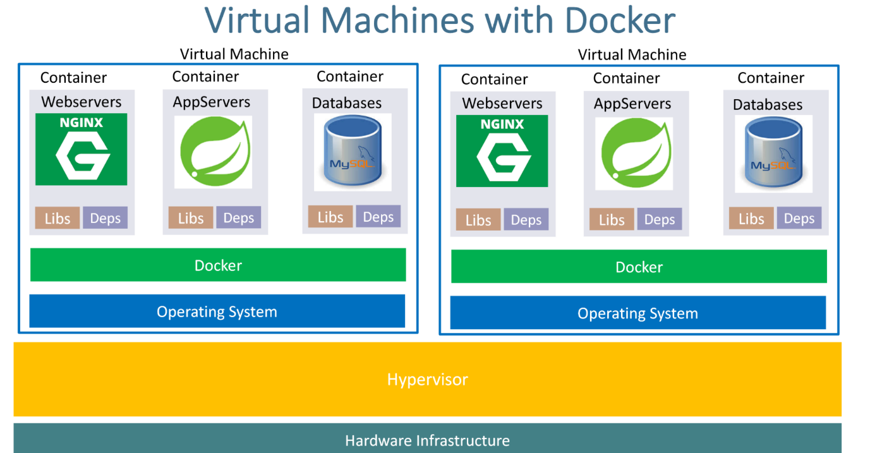

--- we have the hardware infrastructure, on top of that we have operating system. On top of that we deploy our docker images as containers. We can multiple docker containers on single virtual machine.

**Advantages of using docker**

